***Virginia Junior Classical League***

*presents this*

Certificate of Excellence

*to*

Caroline Benedetti

*of*

Trinity Episcopal School

*for*

*1st Place in Greeting Card*

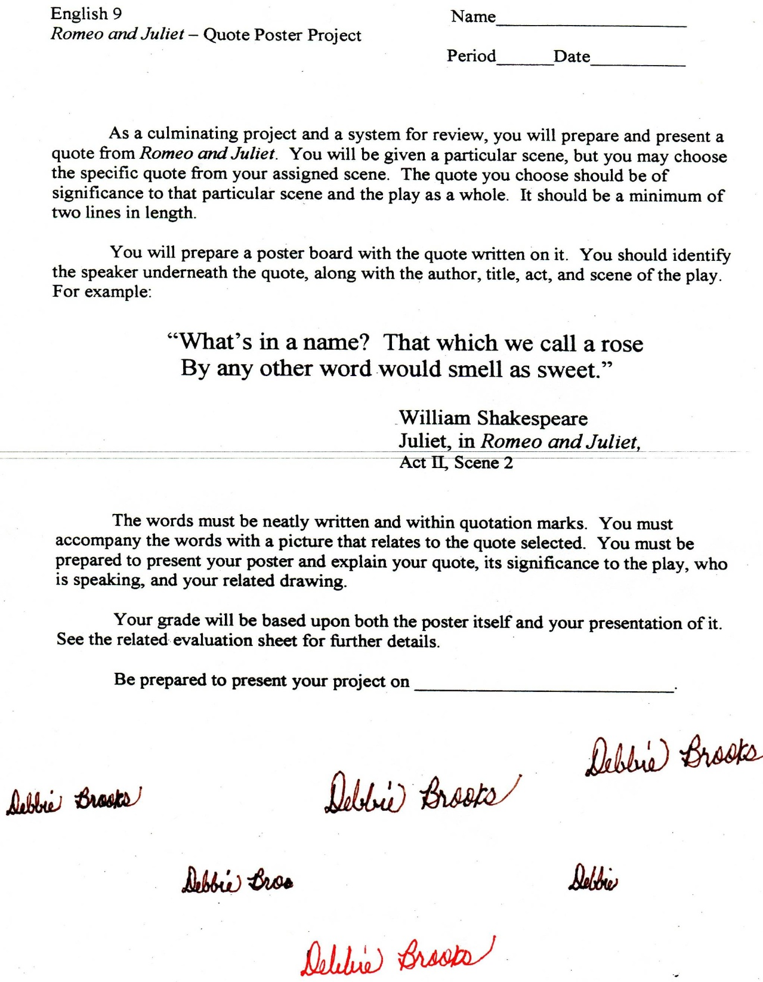

Microsoft Office Signature Line...

*a.d. viii Kal. Dec. MMDCCLXVII A.U.C. 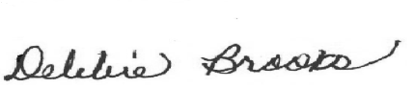*

***Virginia Junior Classical League***

*presents this*

Certificate of Excellence

*to*

Lucy DiLoreto

*of*

Trinity Episcopal School

*for*

*3rd Place in Pottery*

**

Microsoft Office Signature Line...

*a.d. viii Kal. Dec. MMDCCLXVII A.U.C. *

***Virginia Junior Classical League***

*presents this*

Certificate of Excellence

*to*

Diana Kabbani

*of*

Trinity Episcopal School

*for*

*4th Place in Impromptu Art*

**

Microsoft Office Signature Line...

*a.d. viii Kal. Dec. MMDCCLXVII A.U.C. *

***Virginia Junior Classical League***

*presents this*

Certificate of Excellence

*to*

Kailey Kinslow

*of*

Trinity Episcopal School

*for*

*5th Place in Maps*

**

Microsoft Office Signature Line...

*a.d. viii Kal. Dec. MMDCCLXVII A.U.C. *

***Virginia Junior Classical League***

*presents this*

Certificate of Excellence

*to*

Tolliver Mance

*of*

Trinity Episcopal School

*for*

*6th Place in Pentathlon*

**

Microsoft Office Signature Line...

*a.d. viii Kal. Dec. MMDCCLXVII A.U.C. *

***Virginia Junior Classical League***

*presents this*

Certificate of Excellence

*to*

Katie Grotewiel

*of*

Trinity Episcopal School

*for*

*9th Place in Maps*

**

Microsoft Office Signature Line...

*a.d. viii Kal. Dec. MMDCCLXVII A.U.C. *