***Virginia Junior Classical League***

*presents this*

Certificate of Excellence

*to*

Katherine Whittaker

*of*

Massaponax High School

*for*

*3rd Place in Greeting Card*

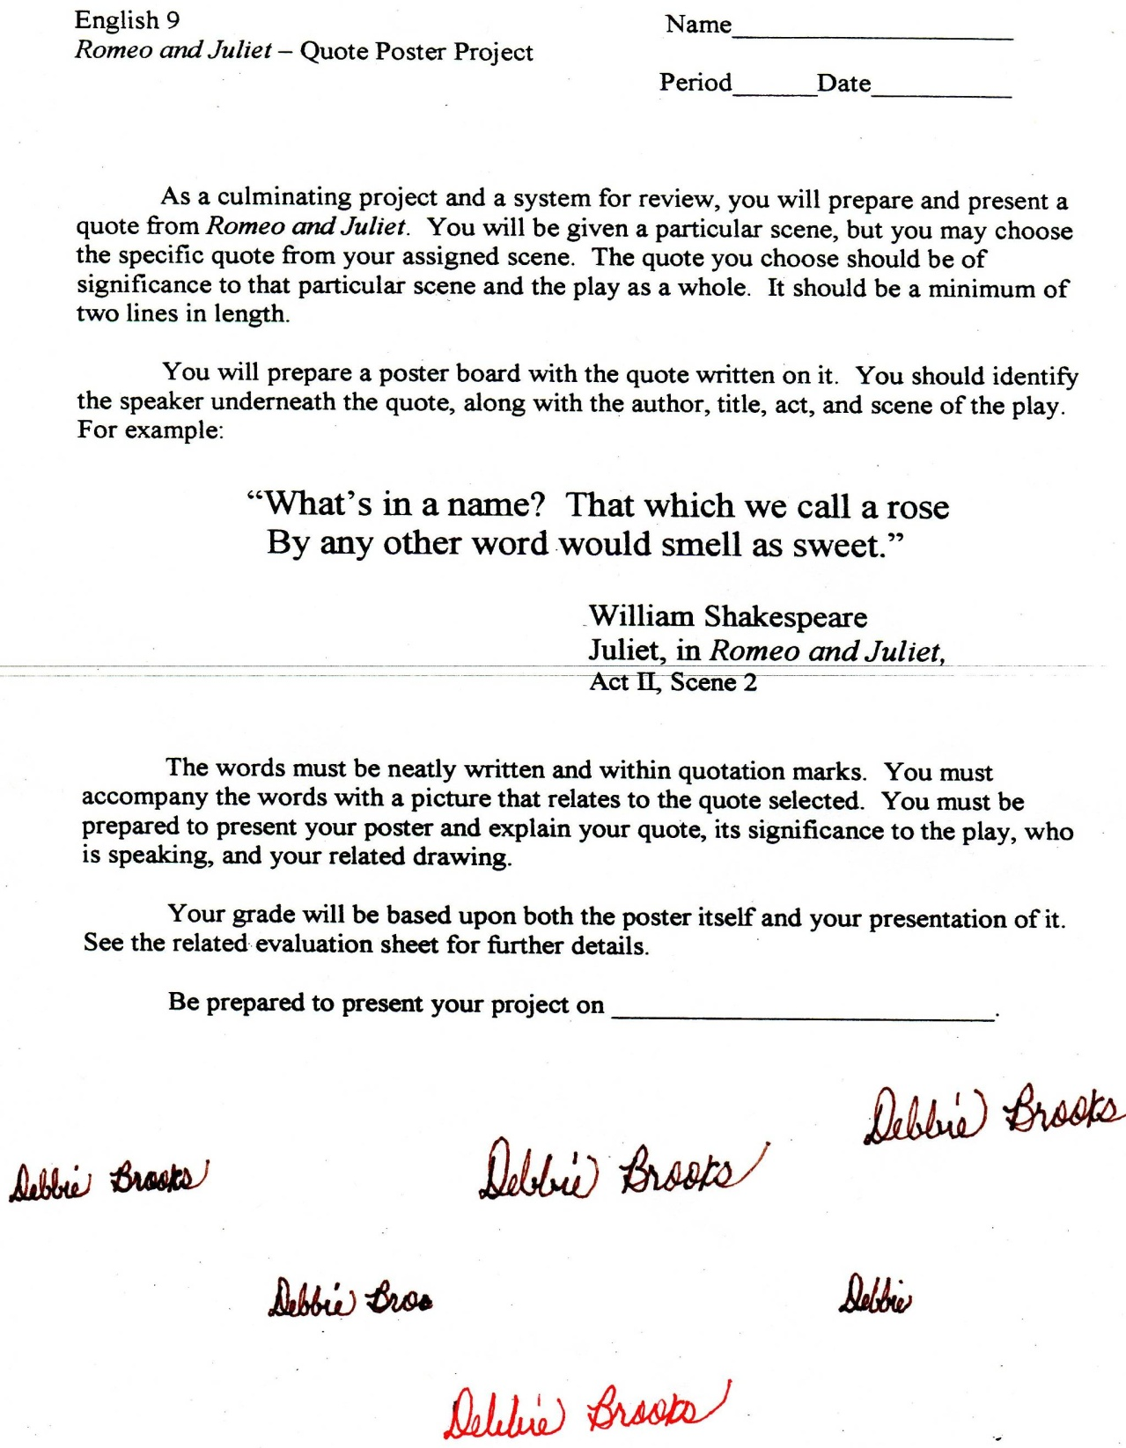

Microsoft Office Signature Line...

*a.d. viii Kal. Dec. MMDCCLXVII A.U.C. 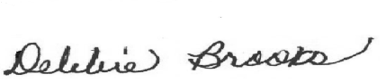*

***Virginia Junior Classical League***

*presents this*

Certificate of Excellence

*to*

Katherine Whittaker

*of*

Massaponax High School

*for*

*5th Place in Jewelry*

**

Microsoft Office Signature Line...

*a.d. viii Kal. Dec. MMDCCLXVII A.U.C. *

***Virginia Junior Classical League***

*presents this*

Certificate of Excellence

*to*

Ian Ward

*of*

Massaponax High School

*for*

*6th Place in Mosaics*

**

Microsoft Office Signature Line...

*a.d. viii Kal. Dec. MMDCCLXVII A.U.C. *

***Virginia Junior Classical League***

*presents this*

Certificate of Excellence

*to*

Ian Ward

*of*

Massaponax High School

*for*

*7th Place in Impromptu Art*

**

Microsoft Office Signature Line...

*a.d. viii Kal. Dec. MMDCCLXVII A.U.C. *

***Virginia Junior Classical League***

*presents this*

Certificate of Excellence

*to*

Ian Ward

*of*

Massaponax High School

*for*

*7th Place in Life*

**

Microsoft Office Signature Line...

*a.d. viii Kal. Dec. MMDCCLXVII A.U.C. *

***Virginia Junior Classical League***

*presents this*

Certificate of Excellence

*to*

Sarah Simmons

*of*

Massaponax High School

*for*

*7th Place in Life*

**

Microsoft Office Signature Line...

*a.d. viii Kal. Dec. MMDCCLXVII A.U.C. *

***Virginia Junior Classical League***

*presents this*

Certificate of Excellence

*to*

Sarah Simmons

*of*

Massaponax High School

*for*

*9th Place in Geography*

**

Microsoft Office Signature Line...

*a.d. viii Kal. Dec. MMDCCLXVII A.U.C. *

***Virginia Junior Classical League***

*presents this*

Certificate of Excellence

*to*

Dev Patel

*of*

Massaponax High School

*for*

*9th Place in Mythology*

**

Microsoft Office Signature Line...

*a.d. viii Kal. Dec. MMDCCLXVII A.U.C. *