***Virginia Junior Classical League***

*presents this*

Certificate of Excellence

*to*

Delaney Flaesh

*of*

The Madeira School

*for*

*2nd Place in Cartoon*

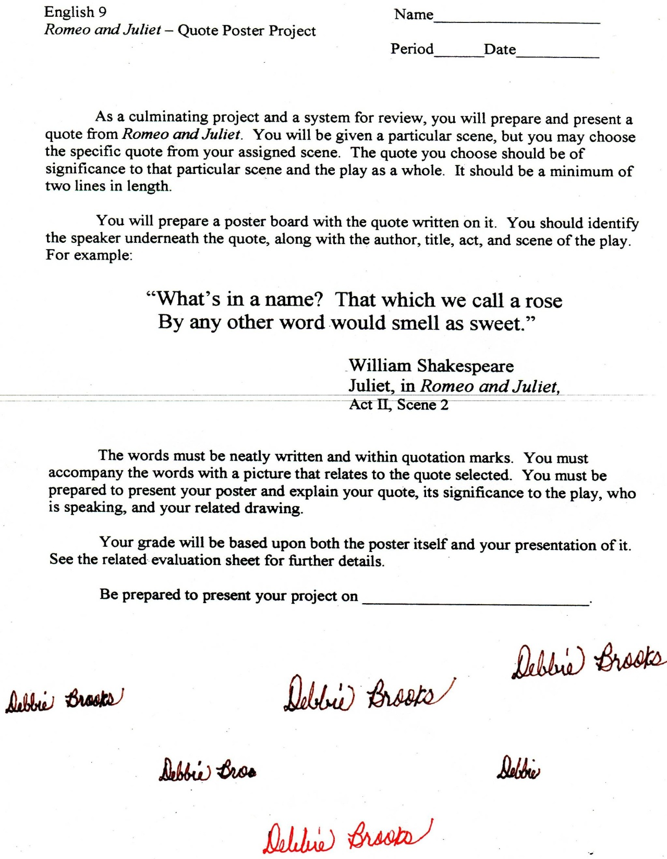

Microsoft Office Signature Line...

*a.d. viii Kal. Dec. MMDCCLXVII A.U.C. 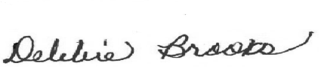*

***Virginia Junior Classical League***

*presents this*

Certificate of Excellence

*to*

Briana Harrington

*of*

The Madeira School

*for*

*2nd Place in Oil*

**

Microsoft Office Signature Line...

*a.d. viii Kal. Dec. MMDCCLXVII A.U.C. *

***Virginia Junior Classical League***

*presents this*

Certificate of Excellence

*to*

Lucy Li

*of*

The Madeira School

*for*

*3rd Place in Reading Comprehension*

**

Microsoft Office Signature Line...

*a.d. viii Kal. Dec. MMDCCLXVII A.U.C. *

***Virginia Junior Classical League***

*presents this*

Certificate of Excellence

*to*

Delaney Flaesh

*of*

The Madeira School

*for*

*5th Place in Oil*

**

Microsoft Office Signature Line...

*a.d. viii Kal. Dec. MMDCCLXVII A.U.C. *

***Virginia Junior Classical League***

*presents this*

Certificate of Excellence

*to*

Ciara O'Donoghue

*of*

The Madeira School

*for*

*7th Place in History*

**

Microsoft Office Signature Line...

*a.d. viii Kal. Dec. MMDCCLXVII A.U.C. *

***Virginia Junior Classical League***

*presents this*

Certificate of Excellence

*to*

Delaney Flaesh

*of*

The Madeira School

*for*

*7th Place in Impromptu Art*

**

Microsoft Office Signature Line...

*a.d. viii Kal. Dec. MMDCCLXVII A.U.C. *

***Virginia Junior Classical League***

*presents this*

Certificate of Excellence

*to*

Lucy Li

*of*

The Madeira School

*for*

*7th Place in Vocabulary*

**

Microsoft Office Signature Line...

*a.d. viii Kal. Dec. MMDCCLXVII A.U.C. *

***Virginia Junior Classical League***

*presents this*

Certificate of Excellence

*to*

Becca Bishof

*of*

The Madeira School

*for*

*8th Place in Mottoes, Quotes, and Abbreviations*

**

Microsoft Office Signature Line...

*a.d. viii Kal. Dec. MMDCCLXVII A.U.C. *

***Virginia Junior Classical League***

*presents this*

Certificate of Excellence

*to*

Lucy Li

*of*

The Madeira School

*for*

*9th Place in Grammar*

**

Microsoft Office Signature Line...

*a.d. viii Kal. Dec. MMDCCLXVII A.U.C. *

***Virginia Junior Classical League***

*presents this*

Certificate of Excellence

*to*

Lucy Li

*of*

The Madeira School

*for*

*9th Place in History*

**

Microsoft Office Signature Line...

*a.d. viii Kal. Dec. MMDCCLXVII A.U.C. *

***Virginia Junior Classical League***

*presents this*

Certificate of Excellence

*to*

Ciara O'Donoghue

*of*

The Madeira School

*for*

*10th Place in Charts*

**

Microsoft Office Signature Line...

*a.d. viii Kal. Dec. MMDCCLXVII A.U.C. *

***Virginia Junior Classical League***

*presents this*

Certificate of Excellence

*to*

Diana Smith

*of*

The Madeira School

*for*

*10th Place in Life*

**

Microsoft Office Signature Line...

*a.d. viii Kal. Dec. MMDCCLXVII A.U.C. *

***Virginia Junior Classical League***

*presents this*

Certificate of Excellence

*to*

Becca Bishof

*of*

The Madeira School

*for*

*10th Place in Pentathlon*

**

Microsoft Office Signature Line...

*a.d. viii Kal. Dec. MMDCCLXVII A.U.C. *