***Virginia Junior Classical League***

*presents this*

Certificate of Excellence

*to*

Madison Munson

*of*

Member at Large

*for*

*1st Place in Costume - Girls Lower Division*

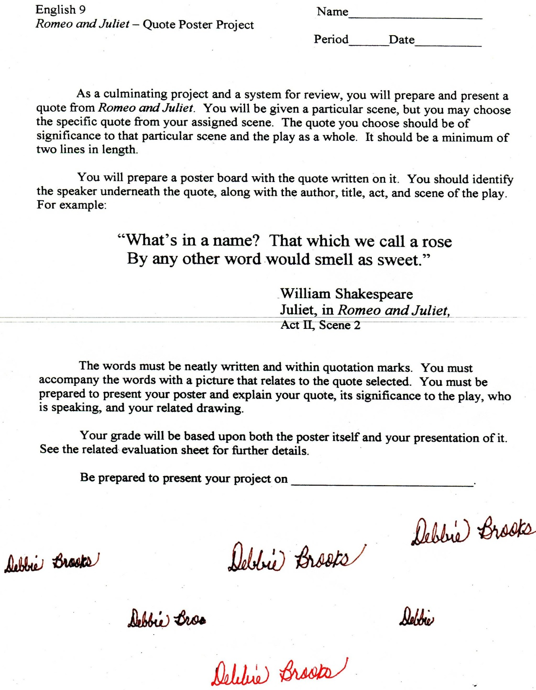

Microsoft Office Signature Line...

*a.d. viii Kal. Dec. MMDCCLXVII A.U.C. 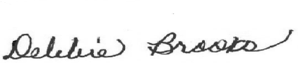*

***Virginia Junior Classical League***

*presents this*

Certificate of Excellence

*to*

Madison Munson

*of*

Member at Large

*for*

*1st Place in Games*

**

Microsoft Office Signature Line...

*a.d. viii Kal. Dec. MMDCCLXVII A.U.C. *

***Virginia Junior Classical League***

*presents this*

Certificate of Excellence

*to*

Madison Munson

*of*

Member at Large

*for*

*1st Place in Ornaments*

**

Microsoft Office Signature Line...

*a.d. viii Kal. Dec. MMDCCLXVII A.U.C. *

***Virginia Junior Classical League***

*presents this*

Certificate of Excellence

*to*

Madison Munson

*of*

Member at Large

*for*

*2nd Place in Other*

**

Microsoft Office Signature Line...

*a.d. viii Kal. Dec. MMDCCLXVII A.U.C. *

***Virginia Junior Classical League***

*presents this*

Certificate of Excellence

*to*

Madison Munson

*of*

Member at Large

*for*

*2nd Place in Other Textiles*

**

Microsoft Office Signature Line...

*a.d. viii Kal. Dec. MMDCCLXVII A.U.C. *

***Virginia Junior Classical League***

*presents this*

Certificate of Excellence

*to*

Madison Munson

*of*

Member at Large

*for*

*2nd Place in Pencil*

**

Microsoft Office Signature Line...

*a.d. viii Kal. Dec. MMDCCLXVII A.U.C. *

***Virginia Junior Classical League***

*presents this*

Certificate of Excellence

*to*

Will Bolton

*of*

Member at Large

*for*

*3rd Place in Geography*

**

Microsoft Office Signature Line...

*a.d. viii Kal. Dec. MMDCCLXVII A.U.C. *

***Virginia Junior Classical League***

*presents this*

Certificate of Excellence

*to*

Madison Munson

*of*

Member at Large

*for*

*3rd Place in Photography*

**

Microsoft Office Signature Line...

*a.d. viii Kal. Dec. MMDCCLXVII A.U.C. *

***Virginia Junior Classical League***

*presents this*

Certificate of Excellence

*to*

Madison Munson

*of*

Member at Large

*for*

*3rd Place in Sculpture*

**

Microsoft Office Signature Line...

*a.d. viii Kal. Dec. MMDCCLXVII A.U.C. *

***Virginia Junior Classical League***

*presents this*

Certificate of Excellence

*to*

Will Bolton

*of*

Member at Large

*for*

*4th Place in History*

**

Microsoft Office Signature Line...

*a.d. viii Kal. Dec. MMDCCLXVII A.U.C. *

***Virginia Junior Classical League***

*presents this*

Certificate of Excellence

*to*

Madison Munson

*of*

Member at Large

*for*

*5th Place in Felt*

**

Microsoft Office Signature Line...

*a.d. viii Kal. Dec. MMDCCLXVII A.U.C. *

***Virginia Junior Classical League***

*presents this*

Certificate of Excellence

*to*

Sarah Andrews

*of*

member at large

*for*

*10th Place in Life*

**

Microsoft Office Signature Line...

*a.d. viii Kal. Dec. MMDCCLXVII A.U.C. *