***Virginia Junior Classical League***

*presents this*

Certificate of Excellence

*to*

Matt Gemmil

*of*

Liberty Middle School

*for*

*1st Place in Vocabulary*

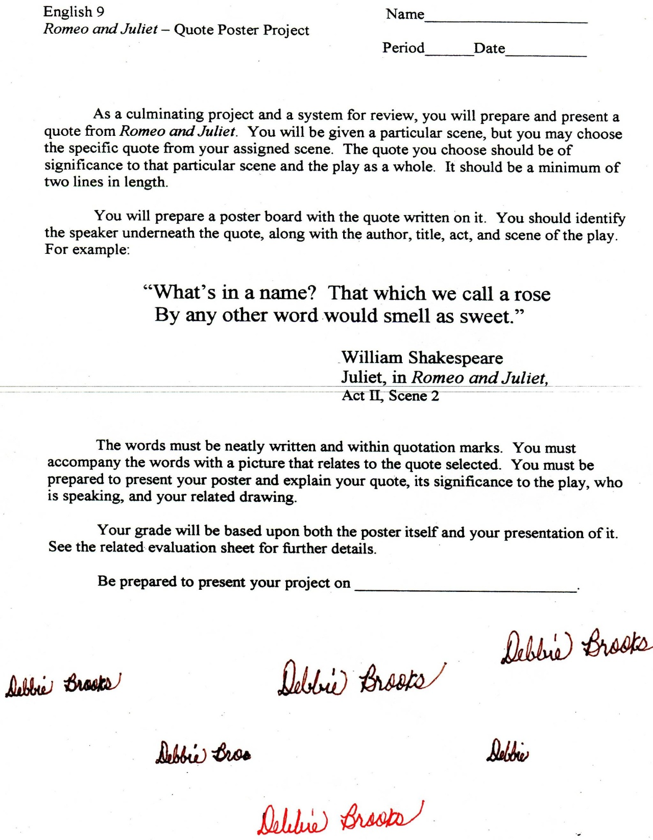

Microsoft Office Signature Line...

*a.d. viii Kal. Dec. MMDCCLXVII A.U.C. 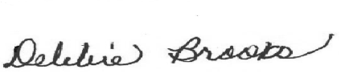*

***Virginia Junior Classical League***

*presents this*

Certificate of Excellence

*to*

Matt Gemmil

*of*

Liberty Middle School

*for*

*2nd Place in Pentathlon*

**

Microsoft Office Signature Line...

*a.d. viii Kal. Dec. MMDCCLXVII A.U.C. *

***Virginia Junior Classical League***

*presents this*

Certificate of Excellence

*to*

Isabelle Giorgis

*of*

Liberty Middle School

*for*

*4th Place in Pentathlon*

**

Microsoft Office Signature Line...

*a.d. viii Kal. Dec. MMDCCLXVII A.U.C. *

***Virginia Junior Classical League***

*presents this*

Certificate of Excellence

*to*

Matt Gemmil

*of*

Liberty Middle School

*for*

*5th Place in Grammar*

**

Microsoft Office Signature Line...

*a.d. viii Kal. Dec. MMDCCLXVII A.U.C. *

***Virginia Junior Classical League***

*presents this*

Certificate of Excellence

*to*

Isabelle Giorgis

*of*

Liberty Middle School

*for*

*5th Place in Vocabulary*

**

Microsoft Office Signature Line...

*a.d. viii Kal. Dec. MMDCCLXVII A.U.C. *

***Virginia Junior Classical League***

*presents this*

Certificate of Excellence

*to*

Matt Gemmil

*of*

Liberty Middle School

*for*

*7th Place in Mythology*

**

Microsoft Office Signature Line...

*a.d. viii Kal. Dec. MMDCCLXVII A.U.C. *