***Virginia Junior Classical League***

*presents this*

Certificate of Excellence

*to*

Libby Snowden

*of*

Kenmore Middle School

*for*

*1st Place in Pentathlon*

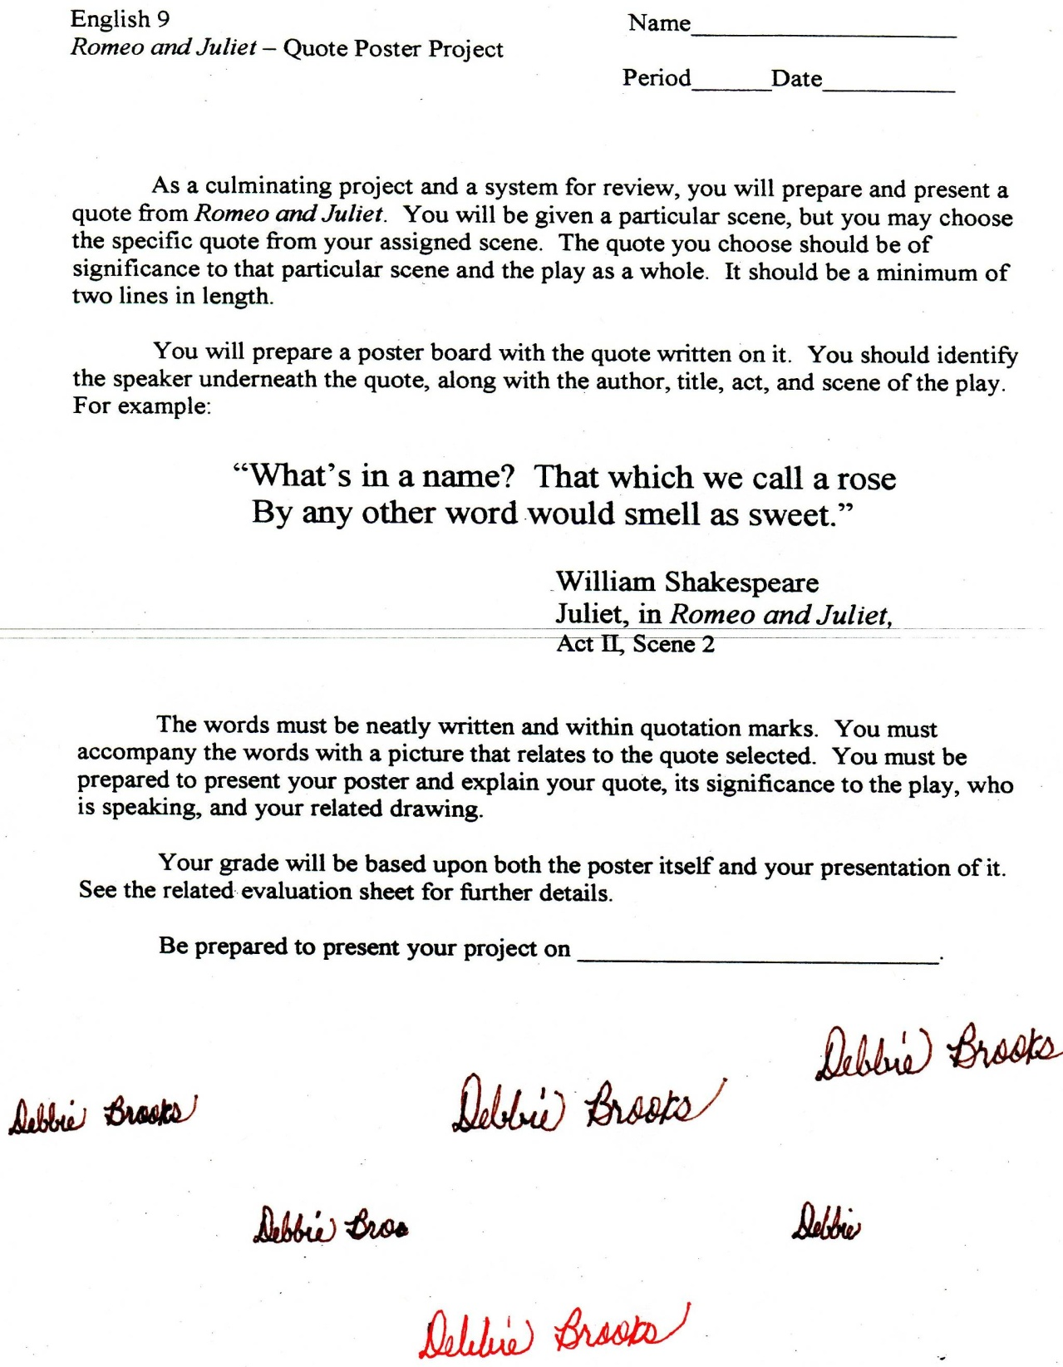

Microsoft Office Signature Line...

*a.d. viii Kal. Dec. MMDCCLXVII A.U.C. 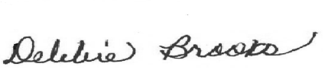*

***Virginia Junior Classical League***

*presents this*

Certificate of Excellence

*to*

Libby Snowden

*of*

Kenmore Middle School

*for*

*4th Place in Derivatives*

**

Microsoft Office Signature Line...

*a.d. viii Kal. Dec. MMDCCLXVII A.U.C. *

***Virginia Junior Classical League***

*presents this*

Certificate of Excellence

*to*

Libby Snowden

*of*

Kenmore Middle School

*for*

*4th Place in Illustrated Quotations*

**

Microsoft Office Signature Line...

*a.d. viii Kal. Dec. MMDCCLXVII A.U.C. *

***Virginia Junior Classical League***

*presents this*

Certificate of Excellence

*to*

Libby Snowden

*of*

Kenmore Middle School

*for*

*4th Place in Mottoes, Quotes, and Abbreviations*

**

Microsoft Office Signature Line...

*a.d. viii Kal. Dec. MMDCCLXVII A.U.C. *

***Virginia Junior Classical League***

*presents this*

Certificate of Excellence

*to*

Sufia Kuddori

*of*

Kenmore Middle School

*for*

*10th Place in Life*

**

Microsoft Office Signature Line...

*a.d. viii Kal. Dec. MMDCCLXVII A.U.C. *