***Virginia Junior Classical League***

*presents this*

Certificate of Excellence

*to*

Sarah Minor

*of*

Cosby High School

*for*

*2nd Place in Costume - Girls Lower Division*

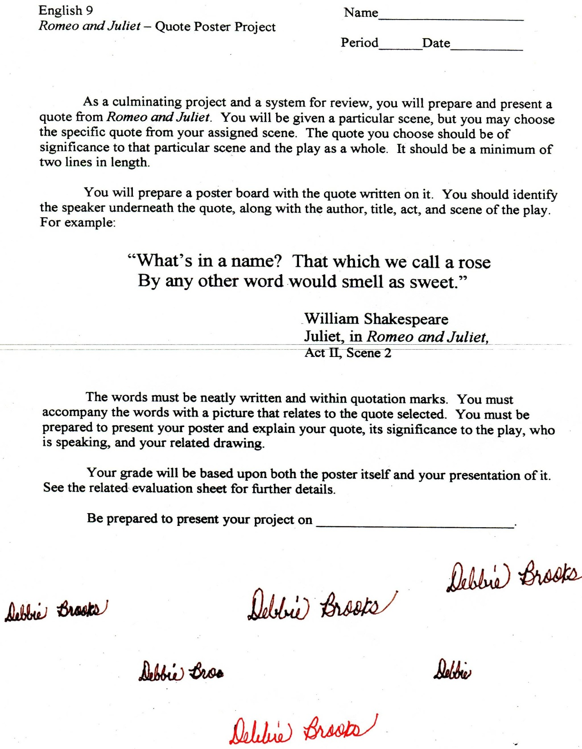

Microsoft Office Signature Line...

*a.d. viii Kal. Dec. MMDCCLXVII A.U.C. 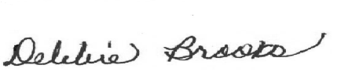*

***Virginia Junior Classical League***

*presents this*

Certificate of Excellence

*to*

Maggie Emery

*of*

Cosby High School

*for*

*2nd Place in Pentathlon*

**

Microsoft Office Signature Line...

*a.d. viii Kal. Dec. MMDCCLXVII A.U.C. *

***Virginia Junior Classical League***

*presents this*

Certificate of Excellence

*to*

Sarah Minor

*of*

Cosby High School

*for*

*3rd Place in Cartoon*

**

Microsoft Office Signature Line...

*a.d. viii Kal. Dec. MMDCCLXVII A.U.C. *

***Virginia Junior Classical League***

*presents this*

Certificate of Excellence

*to*

Sarah Minor

*of*

Cosby High School

*for*

*3rd Place in Children's Book*

**

Microsoft Office Signature Line...

*a.d. viii Kal. Dec. MMDCCLXVII A.U.C. *

***Virginia Junior Classical League***

*presents this*

Certificate of Excellence

*to*

Sarah Minor

*of*

Cosby High School

*for*

*3rd Place in Impromptu Art*

**

Microsoft Office Signature Line...

*a.d. viii Kal. Dec. MMDCCLXVII A.U.C. *

***Virginia Junior Classical League***

*presents this*

Certificate of Excellence

*to*

Grace Layman

*of*

Cosby High School

*for*

*4th Place in History*

**

Microsoft Office Signature Line...

*a.d. viii Kal. Dec. MMDCCLXVII A.U.C. *

***Virginia Junior Classical League***

*presents this*

Certificate of Excellence

*to*

Cole Carawan

*of*

Cosby High School

*for*

*4th Place in Mosaics*

**

Microsoft Office Signature Line...

*a.d. viii Kal. Dec. MMDCCLXVII A.U.C. *

***Virginia Junior Classical League***

*presents this*

Certificate of Excellence

*to*

Sarah Minor

*of*

Cosby High School

*for*

*4th Place in Ornaments*

**

Microsoft Office Signature Line...

*a.d. viii Kal. Dec. MMDCCLXVII A.U.C. *

***Virginia Junior Classical League***

*presents this*

Certificate of Excellence

*to*

Sarah Minor

*of*

Cosby High School

*for*

*5th Place in Dolls*

**

Microsoft Office Signature Line...

*a.d. viii Kal. Dec. MMDCCLXVII A.U.C. *

***Virginia Junior Classical League***

*presents this*

Certificate of Excellence

*to*

Sarah Minor

*of*

Cosby High School

*for*

*5th Place in Mythology*

**

Microsoft Office Signature Line...

*a.d. viii Kal. Dec. MMDCCLXVII A.U.C. *

***Virginia Junior Classical League***

*presents this*

Certificate of Excellence

*to*

Eliza Murtland

*of*

Cosby High School

*for*

*5th Place in Sculpture*

**

Microsoft Office Signature Line...

*a.d. viii Kal. Dec. MMDCCLXVII A.U.C. *

***Virginia Junior Classical League***

*presents this*

Certificate of Excellence

*to*

Shane Perry

*of*

Cosby High School

*for*

*8th Place in Mosaics*

**

Microsoft Office Signature Line...

*a.d. viii Kal. Dec. MMDCCLXVII A.U.C. *