***Virginia Junior Classical League***

*presents this*

Certificate of Excellence

*to*

Daniel Thompson

*of*

Benedictine College Preparatory

*for*

*1st Place in Ink*

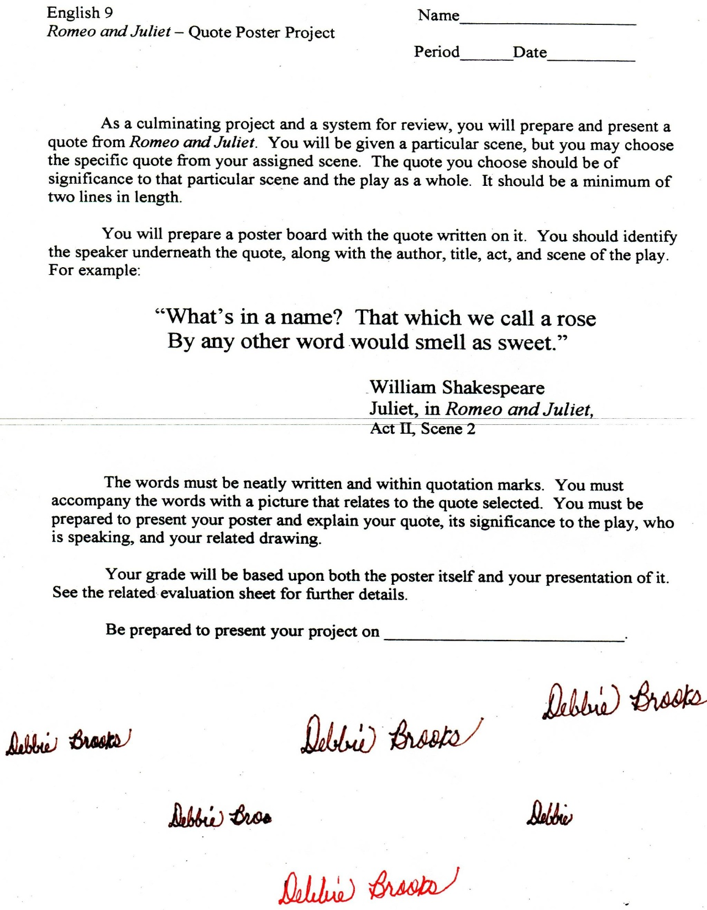

Microsoft Office Signature Line...

*a.d. viii Kal. Dec. MMDCCLXVII A.U.C. 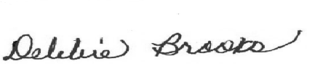*

***Virginia Junior Classical League***

*presents this*

Certificate of Excellence

*to*

Caleb Autry

*of*

Benedictine College Preparatory

*for*

*3rd Place in Ink*

**

Microsoft Office Signature Line...

*a.d. viii Kal. Dec. MMDCCLXVII A.U.C. *

***Virginia Junior Classical League***

*presents this*

Certificate of Excellence

*to*

Caleb Autry

*of*

Benedictine College Preparatory

*for*

*3rd Place in Maps*

**

Microsoft Office Signature Line...

*a.d. viii Kal. Dec. MMDCCLXVII A.U.C. *

***Virginia Junior Classical League***

*presents this*

Certificate of Excellence

*to*

Daniel Thompson

*of*

Benedictine College Preparatory

*for*

*3rd Place in Pottery*

**

Microsoft Office Signature Line...

*a.d. viii Kal. Dec. MMDCCLXVII A.U.C. *

***Virginia Junior Classical League***

*presents this*

Certificate of Excellence

*to*

Gabriel Romito

*of*

Benedictine College Preparatory

*for*

*7th Place in Costume - Boys Upper Division*

**

Microsoft Office Signature Line...

*a.d. viii Kal. Dec. MMDCCLXVII A.U.C. *

***Virginia Junior Classical League***

*presents this*

Certificate of Excellence

*to*

Chris Metzger

*of*

Benedictine College Preparatory

*for*

*7th Place in Ink*

**

Microsoft Office Signature Line...

*a.d. viii Kal. Dec. MMDCCLXVII A.U.C. *

***Virginia Junior Classical League***

*presents this*

Certificate of Excellence

*to*

Gene Kastelberg

*of*

Benedictine College Preparatory

*for*

*8th Place in Ink*

**

Microsoft Office Signature Line...

*a.d. viii Kal. Dec. MMDCCLXVII A.U.C. *

***Virginia Junior Classical League***

*presents this*

Certificate of Excellence

*to*

Travis Lipscomb

*of*

Benedictine College Preparatory

*for*

*10th Place in Life*

**

Microsoft Office Signature Line...

*a.d. viii Kal. Dec. MMDCCLXVII A.U.C. *

***Virginia Junior Classical League***

*presents this*

Certificate of Excellence

*to*

Stephen Franzyshen

*of*

Benedictine College Preparatory

*for*

*10th Place in Small Models*

**

Microsoft Office Signature Line...

*a.d. viii Kal. Dec. MMDCCLXVII A.U.C. *